CONTAINMENT ZONE ALERTING APPLICATION

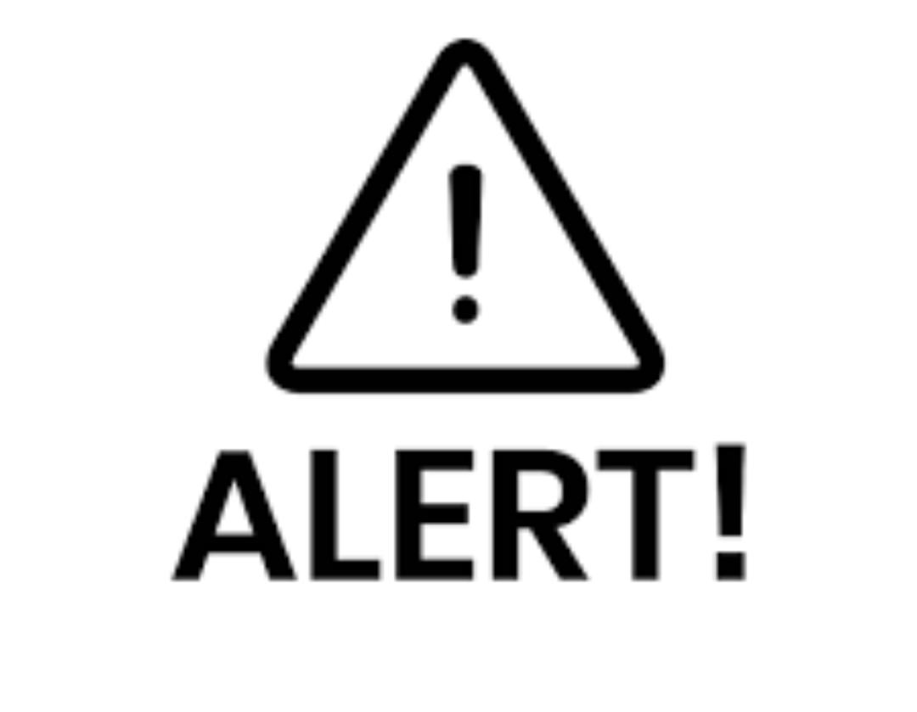

**AGENDA**

CONTAINMENT ZONE ALERTING APPLICATION

-----------------------------------------------------------------------

**What we are doing**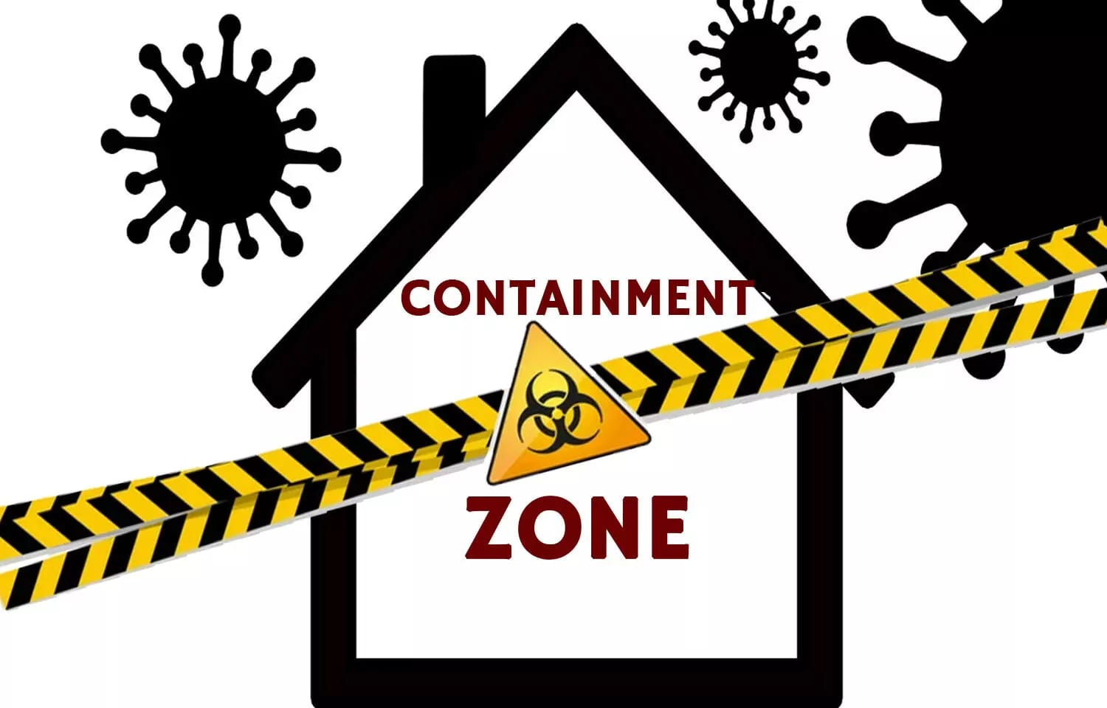

Updates the locations of the areas in google map which are

Identified to be the containment zones.

-----------------------------------------------------------------------

**Steps**

1.Message screen

2.Datasnapshot from cache

3.Containment zones shown in a google map

4.User receives notification

age

# Says

We have used Geofencing and Firebase APIs

(Application Program Interface) from Google as the base for development of this

application.

Does

. The application has been tested in various locations

and has

been found to yield accurate results.

# Thinks Feels

. This application further tracks the user's location and

checks whether it is present in the list of identified containment zones.

destroy properties

Even small actions and small

donations.Make a diifference.

There are things that everyone can do to help

those who need it.

Depending on the situation a rellef group mat need donation of food water are other

suppliers.

In this paper, we mainly focus on developing an android based

application to identify the COVID-19

containment zone in India.

Currently there are several

research works undergoing to prevent COVID- 19

The application

provides an efficient way of showing the identified COVID-19 containment zones to the users in a

Google map

It causes fears

Create

awareness about natura

disasters